Retrieving Exchange ID for DEC/SPS/CREDITS purchase
Introduction
Purchase of assets like DEC/SPS/CREDITS by crypto, is a service provided by a third party called Simpleswap. Incase of any blockers with these transactions, users are directed to Simpleswap support. You will be requested to provide the Exchange ID, which is unique for every transaction.
Following document will help you retrieve the Exchange ID.
Step 1 Login to your Splinterlands account and go to your Currency Activity.
You will find it below your ingame name, on the top right hand side

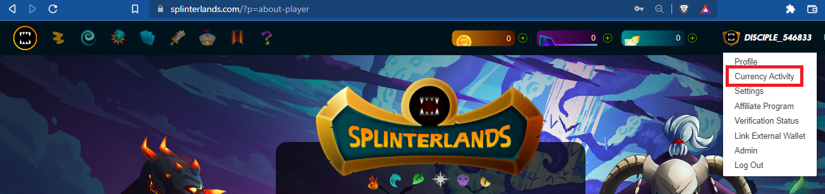

Step 2 Click on currency activity which will show you all records showing the transactions made in that particular account. Select the Exchange History option
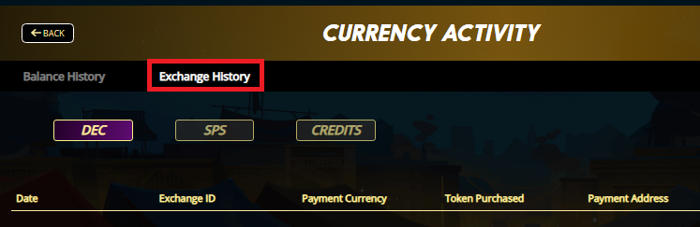

Step3. Here you will see your Exchange ID listed along with the other transaction details.
There will be one row for each transaction, successful or unsuccessful
